**WORK DOCUMENTATION**

**//setting up environment for sending SMS//**

**open The Icare sms server on terminal**

**start the server by node server**

**To connect with mongo db database and the server**

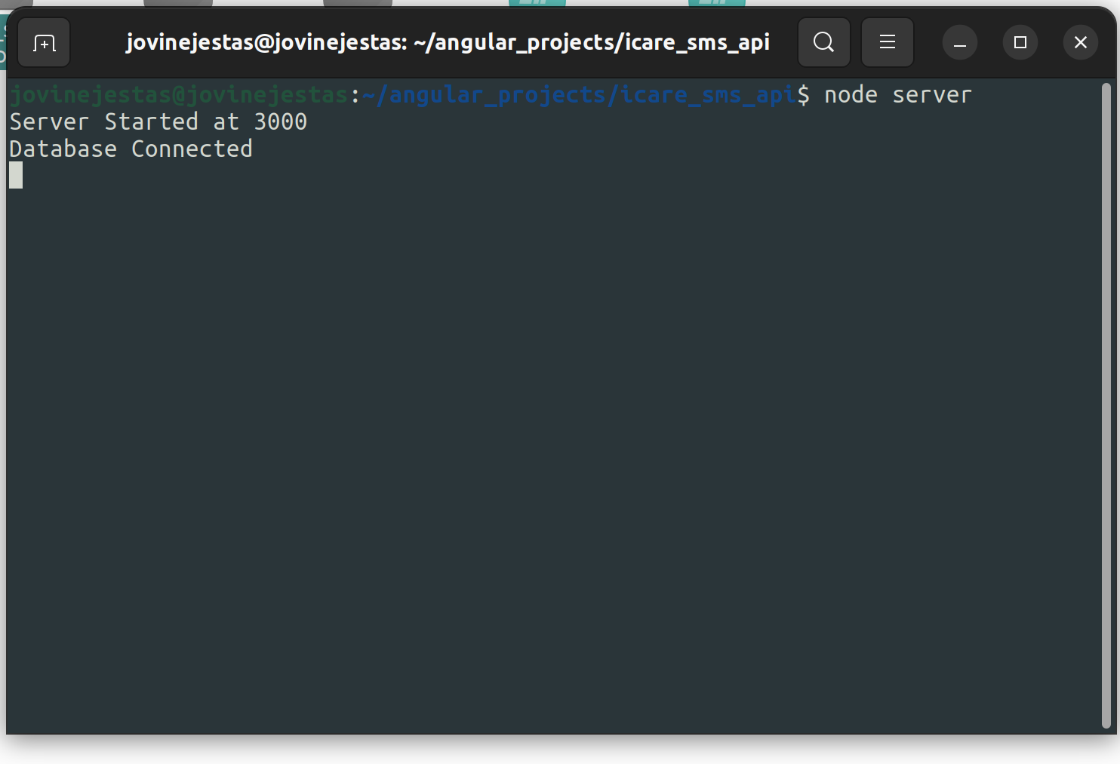

open the ICare web page

Navigate to RCH

For firstly admitted patients

press New appointment button

set the date for appointment on the UI

Time

and the phone number for the patients to be send the message

then save to send message

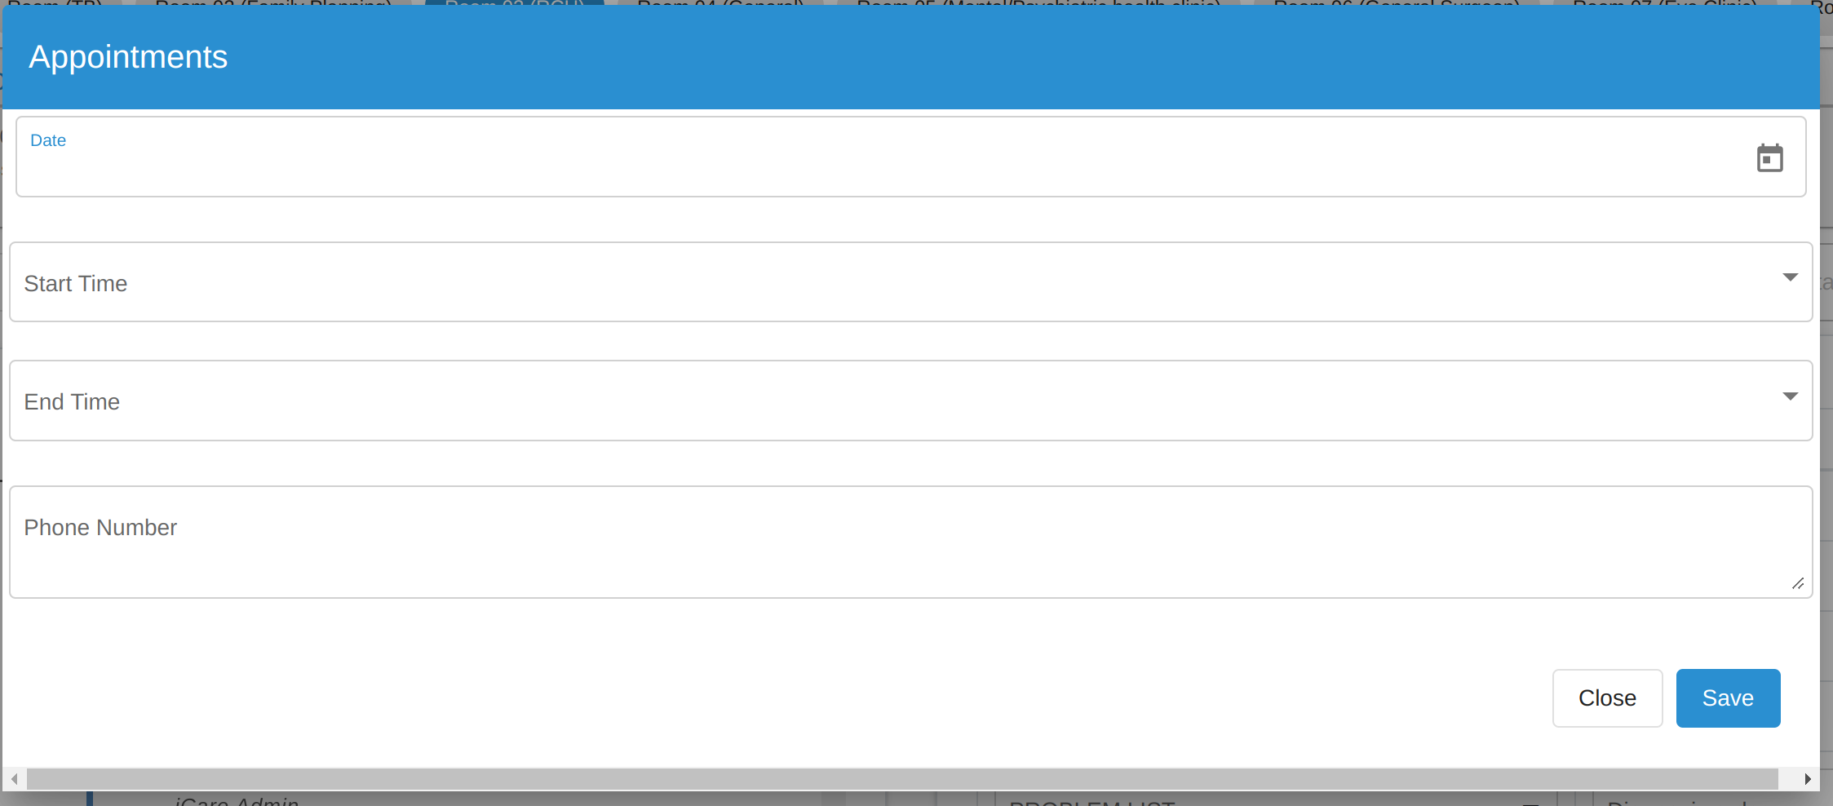

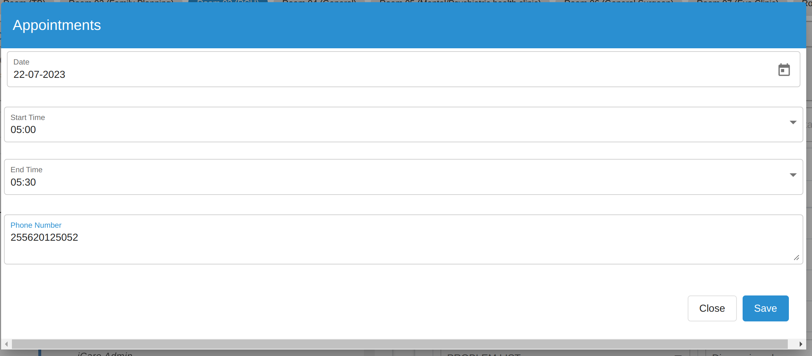

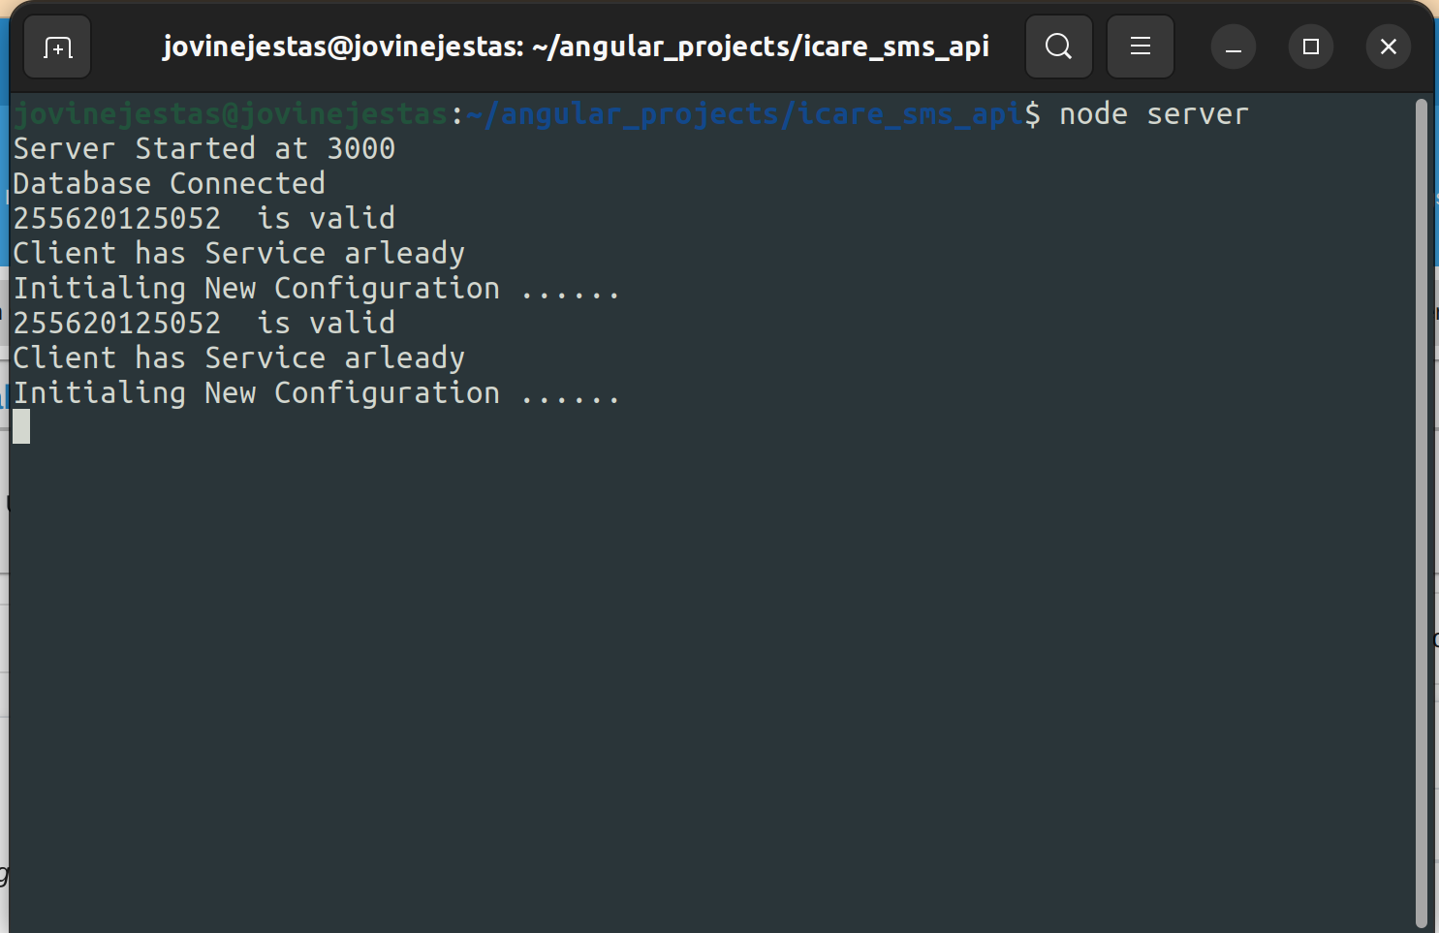

for case of already admitted patient and want change phone number

write the number to change number

number is changed on database of the server

cancel service to start service the start new service

to send the message on new number

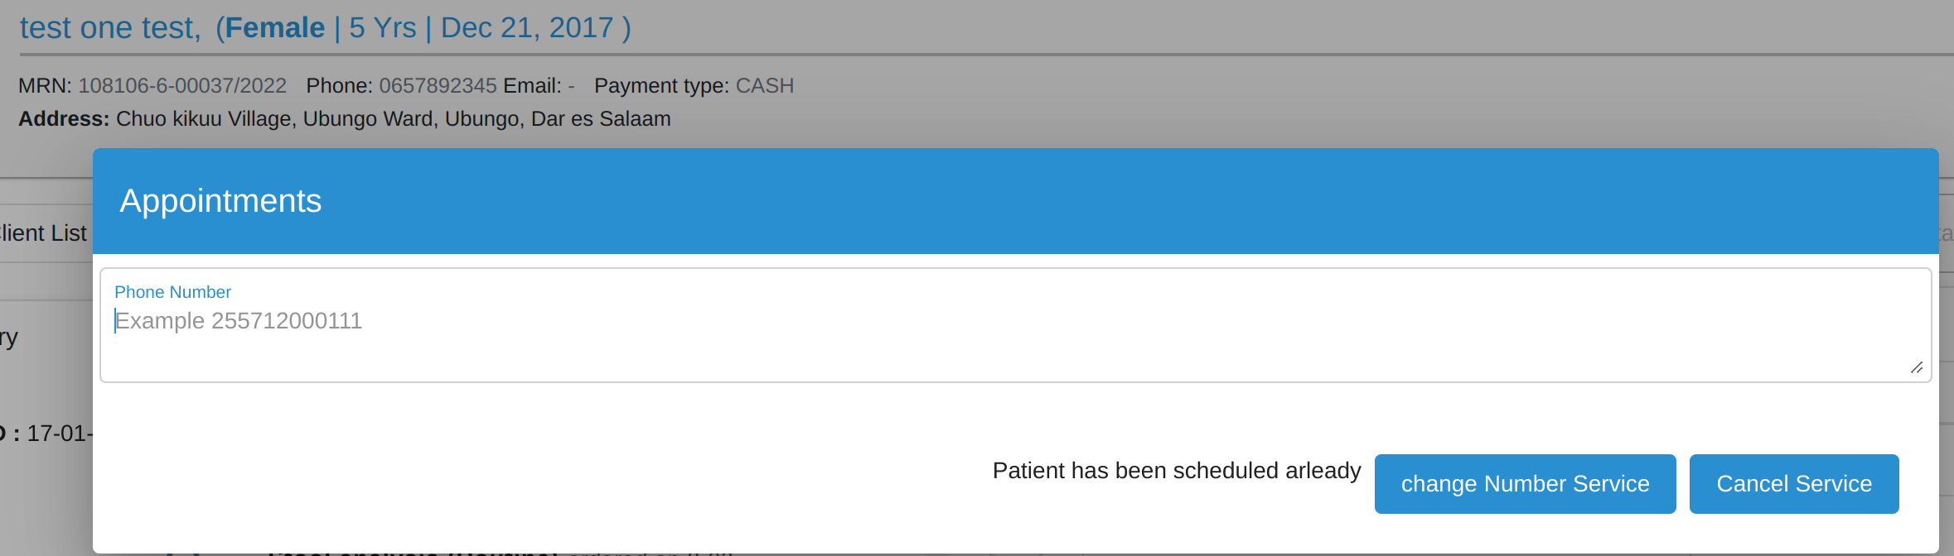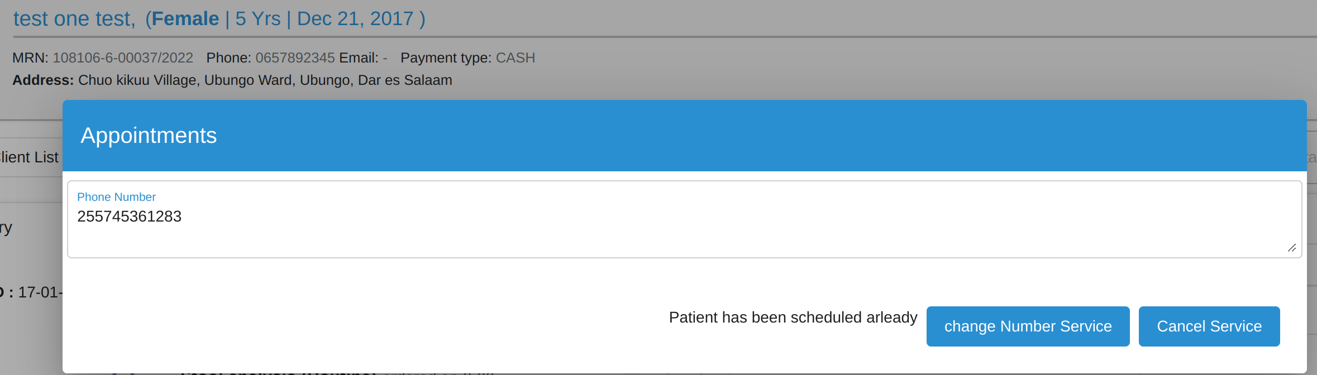

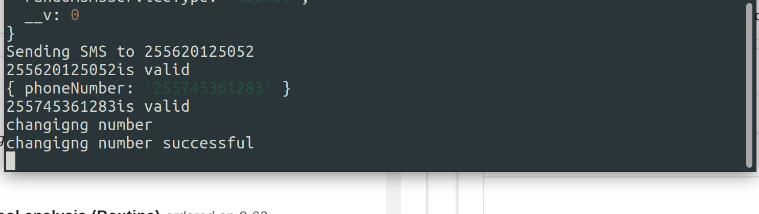

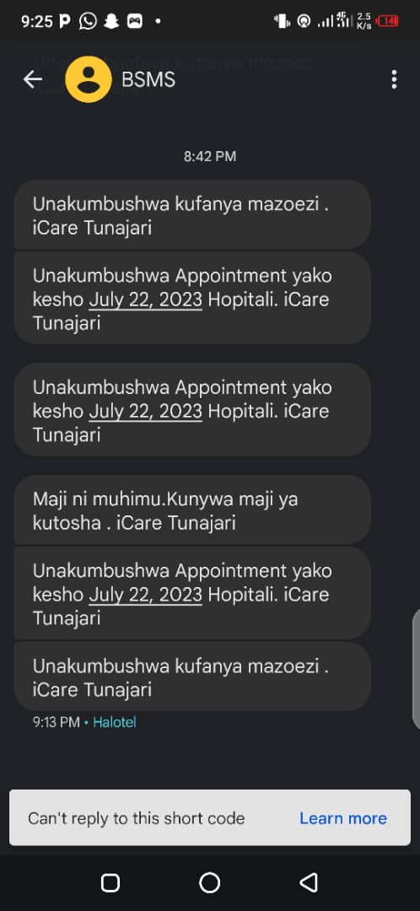

The Antenal clinic form

Antenatal type of visit

The health worker choose the type of clinic visit depending on the reported date

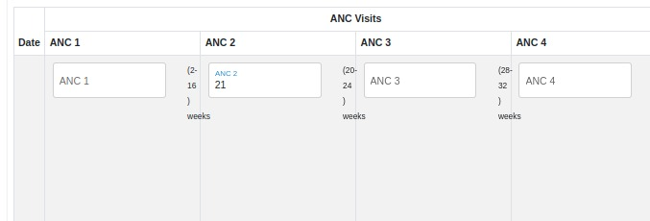

Past medical History

Here past medical data is taken normally recorded on the first ANC visit

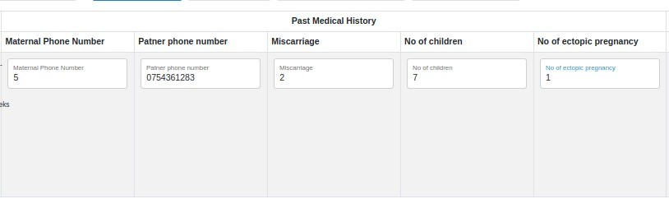

Laboratory Investigation

On every visit laboratory Investigation is perfomed to maternal to determine and checkup their health status

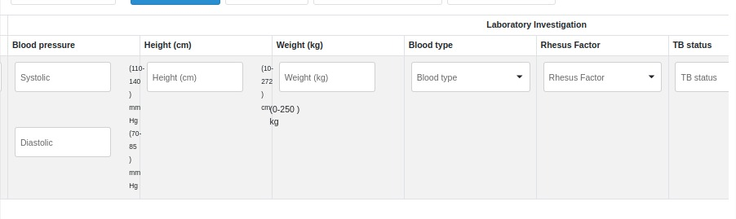

fetal examination

here the fetal is examined on the mothers womb before given birth

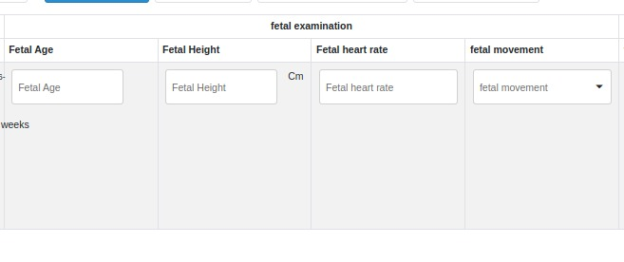Advice and Education and health worker remarks

Here is when doctors give advice to Mothers and give their remarks of attending clinic

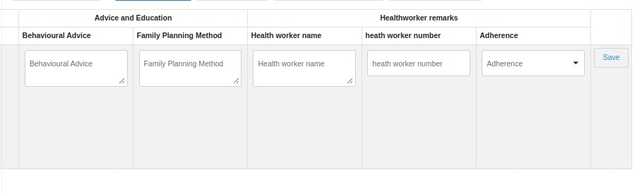Medicine and

Immunization

Here is when medicine is provide to maternal and other necessary medicine needed are recorded

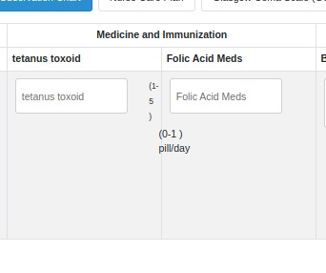

LABOUR PATTERN GRAPH

This is the graph of cervix dillation against time giving doctors trend and patterns which time to determine mother can deliver and concieve and take care measures and at which time can take action during labour

